**CHAPTER ONE**

**1.0 Introduction**

This chapter presents the Background of the study, aim and objectives, significance of the study, statement of the problem, and also scope of the study.

A traffic light, traffic signal or stop light is a signaling device positioned at a road intersection pedestrian crossing, or other location in other locate when it is safe to drive, ride or walk using a universal color code, in many countries the traffic lights for vehicles commonly have three main lights, a red means stop, a green light means go and yellow that means ready to stop, however for the pedestrians, they have only two lights, a red light and a green light that mean go and stop respectively.

The traffic lights have given many to all road users, besides reducing the number of accidents, it made the traffic flow smoothly and possibly could save people time

**1.1 Background of the Study**

The word first traffic light come into being before the automobile was in use and traffic consisted only of pedestrian, buggies and wagon, installed in an intersection in London in 1968 it was a revolving lantern with red and green signals, red means “stop” and green means “caution” the lantern illuminated by gas was turned by means of a lever at it base so that the appropriate light faced traffic, on January 2, 1869 (Ekinhan et al, 2013), this crude traffic light exploded, injuring the policeman who was operating it.

After the coming of automobiles, the situation got even worse, policer William L. Potts of Detroit, Michigan decided to do something about the problem, installed in 1920 on the corner of Woodward and Michigan avenues in Detroit, within a year, Detroit had installed a total of fifteen of the new automatic lights. At about the same time Garrett Morgan of Cleveland, Ohio realized the need to control the flow of traffic (Ekinhan et al, 2013). A gifted inventor and reportedly the first African American to own an automobile in Cleveland, Ohio, he invented the traffic electric automatic traffic light, though it looked more like the semaphore signals you see at train crossing today.

**1.2 Statement of the Problem**

The current system of traffic light has been providing a fixed traffic control plan, which setting are based on prior traffic counts but may be manually changed, it is the most common form of signal control and result The control of traffic takes two main forms, regulatory measures and control device. Regulatory measures include laws and ordinances for the purpose of devices, vehicles and pedestrians control and also laws for controlling vehicle operation in the traffic stream. The fundamental regulatory measures include, intersection controls, turn controls, parking controls, speed controls, one-way operation and unbalance flow.

**1.3 Aim and Objectives of the Study**

The aim of the project is to design and construct an Arduino based three way (T-junction) traffic light using three colors LED red, yellow and green in order to reduce crossing road accident.

* To design the hardware model of an Arduino controlled traffic light
* To interface the traffic system with Arduino with Arduino.
* To Develop the algorithm for the four-way traffic system using Arduino Uno.

**1.4 Significance of the Study**

Overall, traffic lights are essential tools for maintaining safe and efficient traffic flow in urban areas, contributing to the overall well-being of communities and reducing the likelihood of accidents and traffic-related incidents. Traffic lights are crucial elements of modern traffic management and play a vital role in ensuring safety, efficiency, and order on roads. Their usefulness can be summarized as follows:

1. Traffic Control and Safety: Traffic lights regulate the flow of vehicles and pedestrians at intersections, preventing collisions and accidents. By assigning specific time intervals to each direction, traffic lights allow for orderly movement, reducing the risk of crashes and improving overall road safety.

2. Efficient Traffic Flow: Traffic lights help optimize traffic flow, especially during peak hours. By coordinating signals, they minimize congestion and keep traffic moving smoothly. This reduces travel time for commuters and enhances the capacity of roads.

3. Pedestrian Safety: Traffic lights provide designated crossing times for pedestrians, allowing them to safely cross busy roads. This is especially important in urban areas with heavy pedestrian traffic.

4. Public Transportation Management: Traffic lights are often integrated with public transportation systems, providing priority signals for buses and trams. This improves the efficiency of public transportation and encourages more people to use it, reducing the number of private vehicles on the road.

5. Emergency Vehicle Priority: Some modern traffic light systems are equipped with sensors that can detect approaching emergency vehicles. These lights can change to favor the path of the emergency vehicle, enabling faster response times during emergencies.

**1.5 Scope of the Study**

This study covers the design and construction of a four-way traffic control only. The design is not modifiable or reprogrammable.

**CHAPTER TWO**

**2.0 Literature Review**

This chapter presents the review of related literature which include traffic control system, Air traffic control, Train approach signal, Automatic traffic control system and 3-way traffic light system.

The design and construction of an Arduino based T-Junction Traffic Light Control System uses of traffic controlling devices and that this controlling device should include a regulatory color with different light bulbs of different colors with different instruction attached to them.

Suggested that after the achievement of the traffic controlling system, not to be l left out is traffic engineering, which is one of the important aspect of higher engineering since it greatly aids in resolving problems encountered in trafficking. Carter (1961).

Unlike the past even present developing countries where Human being are used to regulate traffic, in the modern technology, automatic operated traffic control system is use.

With the use of this electronic traffic light control system, the deficiencies discovered with the use of man as a traffic warder have been greatly eliminated.

**2.1 Review of Related Literature**

The construction of this project T-Junction Traffic Light Control System, was initiated as a result for controlling vehicle operation in the traffic stream. It is the common form of signal control and result in inappropriate behavior in traffic which differs from that which the plan was based. We decided to come up with this project idea.

Rongrong and Xu (2013) suggested to use the TRANSYT traffic modeling software to find the optimal fixed-time signal plan and VISSIM micro-simulation software to affirm and evaluate the TRANSYT model and to help assess the optimal signal plan; build an adaptive frame signal plan and refined and evaluated the plan using VISSIM with VS-PLUS emulator. Through micro-simulation, it was shown that delay in the adaptive signal control was shortened noticeably than that in the fixed time control.

Jianhua et al (2017) introduced a new method for area-wide traffic signal timing optimization under user equilibrium traffic. The optimization model was formulated as a multi-dimensional search problem aimed to achieve minimized product of the total travel time associated with urban street network and the variance of travel time for unit distance of travel. A genetic algorithm was developed to derive the model solution. A simulation control protocol embedded in PARAMICS software tool capable of conducting area-wide micro simulation is adopted to design the logic frame and function module of the area-wide traffic signal control system. His results shown that mobility improvements are achieved after applying the proposed model along with the genetic algorithm for area-wide signal timing optimization, assessed by extended capacity ratio, and reductions in through and turning movement delays, as well as average and variance of travel time for unit distance of

travel.

Gustav and Giacomo (2014) focused on a class of dynamic feedback traffic signal control policies that are based on a generalized proportional allocation rule. There results in a differential inclusion for which there prove existence and, in the special case of orthogonal phases, uniqueness of continuous solutions via a generalization of the reflection principle. Stability is then proved by interpreting the generalized proportional allocation controllers as minimizes of a certain entropy-like function that is then used as a Lyapunov function for the closed-loop system.

Junchen and Xiaoliang (2018) proposed a group-based signal control approach capable of making decisions based on its understanding of traffic conditions at the intersection level. The control problem is formulated using a framework of stochastic optimal control for multi-agent system in which each signal group is modeled as an intelligent agent. The proposed system is designated to be compatible with the prevailing signal system. The parameters were off-line optimized using a genetic algorithm. Simulation results shown that the proposed adaptive groupbased control system outperforms the optimized GBVA control system mainly because of that’s real-time adaptive learning capacity in response to the changes in traffic demand.

Nasser et al (2011) controlled the movement of traffic on urban streets by determined the appropriate signal timing settings. Proposed algorithm was based on the so-called memetic algorithm that combines the strengths of the genetic algorithm and local search in an adaptive manner. In that used two important techniques for improving the performance of traditional memetic algorithms. First, a systematic neighborhood based simple descent algorithm was employed as a local search to effectively exploit the search space. Second, an indicator scheme was proposed to control the local search application based on the quality and diversity of the search process. The proposed algorithm was coded in the commercial microscopic traffic simulator, AIMSUN, and tested on two difference real world case studies in Brisbane, Australia, and Plock, Poland. The results demonstrated that the proposed algorithm was better than genetic algorithms and fixed-time settings, indicated that the proposed algorithm was an effective solution method for traffic signal optimization problems.

Mohammad et al (2019) utilized RL (Reinforcement learning) algorithms to design adaptive traffic signal controllers called actor-critic adaptive traffic signal controllers (A-CATs controllers). Worked done rested on the integration of three threads: (a) shows performance compared of both discrete and continuous A-CATs controllers in a traffic network with recurred congestion (24-h traffic demand) in the upper downtown core of Tehran city, (b) analysed the effects of different traffic disruptions included opportunistic pedestrians crossing, parking lane, non-recurring congestion, and different levels of sensor noise on the performance of A-CATS controllers, and (c) compared the performance of different function approximators (tile coding and radial basis function) on the learning of A-CATs controllers. First an agentbased traffic simulation of the study area was carried out. Then six different scenarios are conducted to find the best A-CATs controller that was robust enough against different traffic disruptions. They observed that the A-CATs controller based on radial basis function networks (RBF (5)) outperforms others. They said that RBF (5) was benchmarked against controllers of discrete state Qlearning, Bayesian Q-learning, fixed time and actuated controllers; and the results revealed that (RBF (5)) consistently outperforms others.

Huajun et al (2015) captured the interaction between travellers’ route choice and traffic signal control in a coherent framework. They tested their algorithm and control strategy by simulation in OmNet++ (A network communication simulator) and SUMO (Simulation of Urban Mobility) under several scenarios. The simulation results shown that with the proposed dynamic routing, the overall travel cost significantly decreases. It was also shown that the proposed adaptive signal control reduced the average delay effectively, as well as reduced the fluctuation of the average speed within the whole network.

Ekinhan et al (2013) suggested a new method for designing traffic signal timing at oversaturated intersections was expressed “the elimination pairing system”. An object function with vehicle delay and stop-start numbers has been generated. Total cost value has been calculated according to the object function. Obtained results were compared with Webster as a traditional traffic signal timing design method and Transyt 14 signal timing software. While Webster gives exaggerated results, Transyt 14 and Elimination Pairing Systems provided better results. As a result of that study, the elimination pairing system could be used for optimizing the traffic signal timings.

Ishant and Pardeep (201) proposed to replace existed traffic signals with a system that are monitored the traffic flow automatically in traffic signal and sensors are fixed in which so the time feed are made dynamic and automatic by processed the live

detection.

Ramteke et.al. (2012) proposed FPGA (Field Programmable Gate Array) controller based on Neuro-Fuzzy system thought provided effective solution for Traffic Control. It can have used to minimize drawbacks of the conventional traffic controllers with the accuracy of provided variation in green cycle intervals based on the heavy traffic loads that changed at every lane in a four leg intersection.

Naren and Srivathsan (2010) introduced an adaptive predictive signal control system that performed real time queue length estimation and employed an efficient signal coordination algorithm with APTTCA-based system.

Pavan and Kamala kumara (2017) studied adaptive traffic control systems with VANET, focused on reliable traffic prediction approaches and various types of adaptive traffic control algorithms also proposed a mobile crowd sensing technology to support dynamic route choices for drivers to avoid congestion. Suggested crowd sourcing can be one of the best options for Adaptive traffic control system for India.

**2.2 Theoretical Review**

***2.2.1 Traffic Control System***

The traffic light system used in most urban areas for controlling traffic is a common example of traffic system controlling vehicular movement such as airplanes, trains, automobile and even pedestrians. Traffic control system ensure safe and orderly movement off airplane at airports during periods of heavy traffic. They also provide efficient movement along rails; cars from one point to another, reduce congestion and also provide smooth flow of traffic along busy roads metropolitan area.

The responsiveness of the vehicle operator, the nature of the vehicle, severity of the traffic problem and requirement placed upon the traffic control system all determine the nature and complexity of the traffic control system. The various types of traffic control are further detailed by Lynw. (1986)

1. **Flash Light:** With this method control, flashing red ‘stop’ light warns the road user of an on – coming train. The flashing red ‘stop’ signals may be electrically or mechanically controlled. Douglas. (1987);
2. **Wig – Wag Signals:** This is quite similar to the flashing light methods except for the fact that a swimming disc with a red light enclose in it is used to give signal that a train is approaching. Hontwritz and Hill. (1996);

***2.2.3 Automatic Traffic Control System***

A traffic light system is the basis circuit used in automobile traffic control systems. It is a system that controls or regulates the movement of automobiles.

The system is meant to operate at a point where automobile from different approaches of the roads met to change direction of movement. The road approaches could be of 5- ways, 4- ways or 3- ways junction. In this case, a 3- way or T – junction with a roundabout constructed within the junction is considered. Boylestad. and Washisky. (2005);

***2.2.4 4-Way Traffic Light System***

Intersection influence the movement and safety of traffic flow so much that the study of their characteristics is important. Road users mutually adjust their preference in order to avoid conclusion with each other.

The circuits have been constructed to have an output of light flash contained in water light with the partitions. Each bulb is placed in a partition in the flowing by amber (yellow) and the green bulb at the bottom.

* The red light means ‘stop’ and wait behind the stop line on the carriage-way.
* Amber (yellow) means ‘get ready to go’.
* Green light means you may go only if the maybe is car.

The pad sense the movement, and thus send out and appropriate signal to the controller, which execute the necessary logic for the required green time.

This project is being designed and constructed so that the lighting box is installed at a site within the junction in such a way that It could be properly visualized by the users of the road.

Project is aim to solving the problem of accident casualties involving passer –by and users of mobile and automobile system such as cars, motorcycles, bicycles truck pusher etc. Such user of road will only benefit if instruction is strictly adhered to (Obeyed). It will go a long way in greatly reducing or minimizing road accidents. Graham. (1991);

**CHAPTER THREE**

**3.0 System Design and Analysis**

This chapter contains a thorough step by step design analysis which involve a description and justification, calculation, reasoning, simulations, codes, materials and methods, theoretical approaches, experimental designs (including statistical analysis) used to achieve the stated objectives of the study undertaken.

**3.1**  **Functional Block Diagram**

The system is made up of several blocks as given in the block diagram on figure 3.1.

|  |
| --- |
| Power Supply |

|  |
| --- |
| Microcontroller |

|  |
| --- |
| 4 set of 3LED Output |

Figure 3.1: Block diagram of the four-way traffic control system.

The system consists of three basic blocks, the power supply, the microcontroller and the indicators.

The power supply is a 9V PP3 type dry cell to offer bias to the whole system. The microcontroller is the heart of the system which is programmed to cause the LEDs to light up at the right order and timing. While the indicators or LEDs convert the electrical signal from the microcontroller to light at different colors.

**3.2 System Design**

***3.2.1 Hardware Design Analysis***

***3.2.1.1 Power Supply***

Every microcontroller needs a power supply able to execute its code. The microcontroller used in this project (PIC16F19390) need between 1.8volt to 5.5volt (microcontroller PIC16F1939 datasheet, 1999). In this design there are two power sources; a 5 volt dc power supply and as 5volt, 230mA dc power from lithium polymer (liPo) batteries.

**3.3.1.2 5 Volt Dc Power Supply**

**LM 7805**

OUTPUT 5V

C1

470µf

C2

10µf

R1

10kΩ

D1

LED

9V

Figure 3.2: 5V DC Power Supply.

The circuit below shows the design of the 5-volt DC power supply used in the project.

The input to the power is a 9-volt battery which is the regulated down to 5 volts. It’s the microcontroller makes its energy demands from the 5V power supply the voltage drop below 5V rapidly. This could make the microcontroller unstable and so both the 470uf and 10uf as selected to ensure it smooth and rappel free microcontroller.

A power supply is defined as a unit that supplies electrical power to another unit. It is one of the most important sub-systems in any electronic system. They are of different type, proper selection of the suitable type of a particular system is very important. It is an affordable, reliable, dedicated low-power solution to provide sufficient energy to your application. Ideally used in circuits with low power consumption so that it can work for longer durations.

This battery is a high capacity & low cost solution for many electronic devices. It is used with its specific battery snap, connector or clip. Sealed in original package Model: 6F22M System: Zinc Carbon Nominal Voltage(V) :9V Discharge Resistance(Ω): 620 Cut-off Voltage(V): 5.4 DISCHARGE TIME:270HM,9HOURS Jacket: Metal Operating Temperature Range: (deg. C)** -20 to +85 Weight : (g)*** 2.0 Dimensions : 26. 5 H x 48. 5 W x 17. 5 L (mm) CERTIFICATION: ULCEROHSISO9001~2000 * Nominal capacity indicates duration until the voltage drops down, when discharged at a nominal discharge current at 20 deg. C. ** When using these batteries at temperatures outside the range of 0 to +40 deg.

To supply 5v dc to the controller an LM7805 fixe voltage regulator is used as shown in figure below:

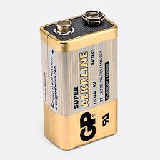

*Figure 3.3: The battery type*

***3.2.1.2 The Microcontroller***

The main component in this design is the microcontroller with the coordination and control function. The microcontroller chosen for the work is the Arduino nano. Arduino Nano is a small, complete, and breadboard-friendly board based on the ATmega328 (Arduino Nano 3.x).

The Arduino Nano can be powered via the Mini-B USB connection, 6-20V unregulated external power supply (pin 30), or 5V regulated external power supply (pin 27). The Arduino microcontroller was used in this design because of the relative ease of programming and also because of its teaming community available online

Memory

The ATmega328 has 32 KB, (also with 2 KB used for the bootloader. The ATmega328 has 2 KB of SRAM and 1 KB of EEPROM.

Input and Output

Each of the 14 digital pins on the Nano can be used as an input or output, using pinMode(), digitalWrite(), and digitalRead() functions. They operate at 5 volts. Each pin can provide or receive a maximum of 40 mA and has an internal pull-up resistor (disconnected by default) of 20-50 kOhms. (ATmega datasheet, 2010). Serial: 0 (RX) and 1 (TX). Used to receive (RX) and transmit (TX) TTL serial data. These pins are connected to the corresponding pins of the FTDI USB-to-TTL Serial chip. External Interrupts: 2 and 3. (Coup, 2012).

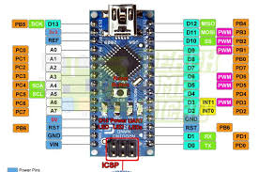

*Figure 3.4: The Arduino Nano*

***3.2.1.3 The Indictors***

A light-emitting diode is a two-lead semiconductor light source. It is a p–n junction diode that emits light when activated. When a suitable voltage is applied to the leads, electrons are able to recombine with electron holes within the device, releasing energy in the form of photons. This effect is called electroluminescence, and the color of the light (corresponding to the energy of the photon) is determined by the energy band gap of the semiconductor. The material used in LEDs is basically aluminum-gallium-arsenide (AlGaAs). In its original state, the atoms of this material are strongly bonded. Without free electrons, conduction of electricity becomes impossible here. By adding an impurity, which is known as doping, extra atoms are introduced, effectively disturbing the balance of the material. These impurities in the form of additional atoms are able either to provide free electrons (N-type) into the system or suck out some of the already existing electrons from the atoms (P-Type) creating “holes” in the atomic orbits. In both ways the material is rendered more conductive. Thus, in the influence of an electric current in N-type of material, the electrons are able to travel from anode (positive) to the cathode (negative) and vice versa in the P-type of material.

To determine the value of the voltage dropper resistor the voltage supply blue must be known. From the value, the characteristics voltage drop of an LED can then be subtracted, and the value of drop across an LED depending on the desired brightness and colour will range from 1.2V to 3.0V

If (max) = 20mA

Vcc = 9V

Vf = 2V

Required corent (rg) = 5mA

RLED = Vcc – Vf (3.2.2.14)

If (max)

= 9 – 2

5 × 10-3

= 1.4 kΩ

But choosing I α LED = 10 mA

R LED = 9 – 2

10 × 10-3

= 0.7 kΩ

Where Vf = the maximum forward voltage drop

Vcc = the supply voltage.

R LED = the LED current limiting resistor

R1 and R12 are choosen to be 1kΩ

Advantages of LEDs:

i. Very low voltage and current are enough to drive the LED. Voltage range – 1 to 2 volts. Current – 5 to 20 mill amperes.

ii. Total power output will be less than 150 mill watts.

iii. The response time is very less – only about 10 nanoseconds.

iv. The device does not need any heating and warm up time.

v. Miniature in size and hence lightweight.

vi. Have a rugged construction and hence can withstand shock and vibrations.

vii. An LED has a lifespan of more than 20 years.

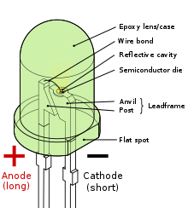

Figure 3.6: LED structure

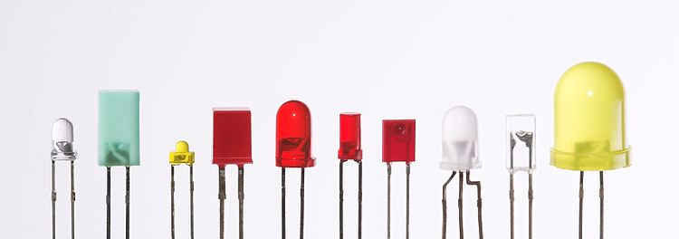

Figure 3.7: LED types

***3.2.2 Software Design Analysis***

***3.2.2.1 Flowchart of the System***

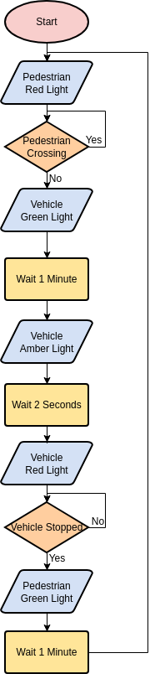

Figure 3.8: Flow chart of the program

***3.2.2.2 Software System Section***

To direct the microcontroller to execute instructions, a program is written in C+ language. The program specifies the inputs and output channels of the microcontroller to be used for the project. After initialization whenever the infra-red field in the field of view of the sensor is disturbed by an intruder the output pin of the sensor goes high thereby triggering the start of the program to control the alarm and or output control to external loads like extra security lighting systems. A summary of the codes written are shown below

Table 3.1: C++ codes for Traffic Light

|  |
| --- |
| int GREEN = 2;  int YELLOW = 3;  int RED = 4;  int DELAY_GREEN = 5000;  int DELAY_YELLOW = 2000;  int DELAY_RED = 5000;  // basic functions  void setup()  pinMode(GREEN, OUTPUT);  pinMode(YELLOW, OUTPUT);  pinMode(RED, OUTPUT);  } void loop()  green_light();  delay(DELAY_GREEN);  yellow_light();  delay(DELAY_YELLOW);  red_light();  delay(DELAY_RED);  } void loop()  green_light();  delay(DELAY_GREEN);  yellow_light();  delay(DELAY_YELLOW);  red_light();  delay(DELAY_RED); |

**3.3 System Construction**

Figure 3.9 represents the design of the four-way intersection with an IR sensor module. Here, the roads A, B, C, and D are represented, and the arrows in each lane show how traffic moves along each road. The IR transmitter and the photodiode receiver of the IR sensors, designated as IR 1 and IR 2, are facing road D. In the same way, IR 3, IR 4, IR 5, IR 6, IR 7, IR 8 are for Road A and Road B and C, respectively

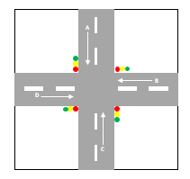

Figure 3.9: Four-way Junction

***3.3.1 Components List***

The components obtained from election and or calculation above are hereby listed.

*Table 3.2: Component List*

|  |  |  |  |
| --- | --- | --- | --- |
| S/N | Component | Type | Quantity |
| 1 | Microcontroller | Arduino Nano(ATmega328) | 1 |
| 2 | 9V battery | PP3 | 1 |
| 3 | Resistor | 1k | 4 |
| 4 | LED | Red,Green, Yellow | 12 |

***3.3.2 Components Layout***

The components are laid down on the protoboard based on their actual connections on the circuit diagram. The layout is given in figure 3.5.

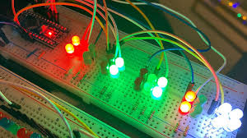

*Figure 3.10: Component layout*

A Vero board is a printed circuit with predrilled holes for ICs and other components but with no inter-connections load on the board itself rather length of insulated wires are used for wiring.

The major consideration in assembling the components on the Vero board was to obtain a neat layout that will make the best use of the board as well as to ensure easy accessibility to each component.

Soldering was done with 15w soldering iron with a pointed copper tip. The soldering lead used had flux in it so that all that was required was to apply the soldering iron to the terminal to be soldered and then put the solder that melts and flows around the joints, care was taken not to apply the iron for more than 10 seconds at a time too any device to avoid damage.

A solder sucker was used to remove unwanted lead or to correct errors, while an engineering knife was employed in cutting unwanted tracks. After soldering was completed, a side cutter was used to snip off excess terminals neat and tidy finishing.

***3.3.3 Components Soldering***

Soldering is an act of joining different types of metals together by melting solder. Solder is a metal alloy usually made of tin and lead which is melted using a hot iron. The iron is heated to temperatures above 600 degrees Fahrenheit which then cools to create a strong electrical bond. A soldering iron is a hand tool used in soldering. It supplies heat to melt solder so that it can flow into the joint between two workpieces.

The components are given a more general designated number which is almost consistent from one Vero board to another with soldering lead and care was taken not to use un-necessary long wires.

Care was also taken in soldering of all active components so as to avoid damage due to excessive heat.

A soldering iron having a low power rating of 40 watts at 250c was used to avoid dry joint and short circuit.

The following tools were used to accomplish the soldering and de-soldering task

i. Soldering iron

ii. Metal brush and file

iii. Lead

iv. Long nose plier and wire cutter

v. Lead sucker

The Vero-board was cleansed with metal brush and lead of each component was measured and excess was cut off to avoid short circuiting care was taken to ensure that the components were fixed properly as shown in the schematic diagram.

A soldering iron is composed of a heated metal tip and an insulated handle. Heating is often achieved electrically, by passing an electric current (supplied through an electrical cord or battery cables) through a resistive heating element.

The following dos and don’ts were taken into consideration while carrying out the soldering

i. Never touch the hot end of the soldering iron (~370 o C) If you do get burnt run your finger under cold water for 5 minutes

ii. Don’t burn the table, the power leads, keyboards, your classmates

iii. Don’t melt anything except solder When not in use put the soldering iron back on the stand (not on the table)

iv. Wear safety glasses, solder can flick into your eye

v. Wash your hands well after soldering (solder is 40% lead)

vi. Use the fume extractors and don’t breathe in the solder fumes

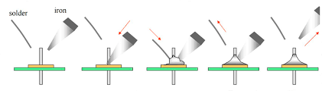

*Figure 3.11: Soldering process*

Finally, the whole soldering processes was accomplished.

***3.3.4 Casing/Packaging***

After assembling the circuit on Vero board, the next step as to provide some form of housing for it. The main purpose is casing of the device is meant to serve for:

* Mechanical support
* Protection of the more delicate parts of the circuit
* More also aesthetical beauty is also put into considerations with regards to the minimum size and weight of the entire case.

The housing was drawn to size the rough prototype.

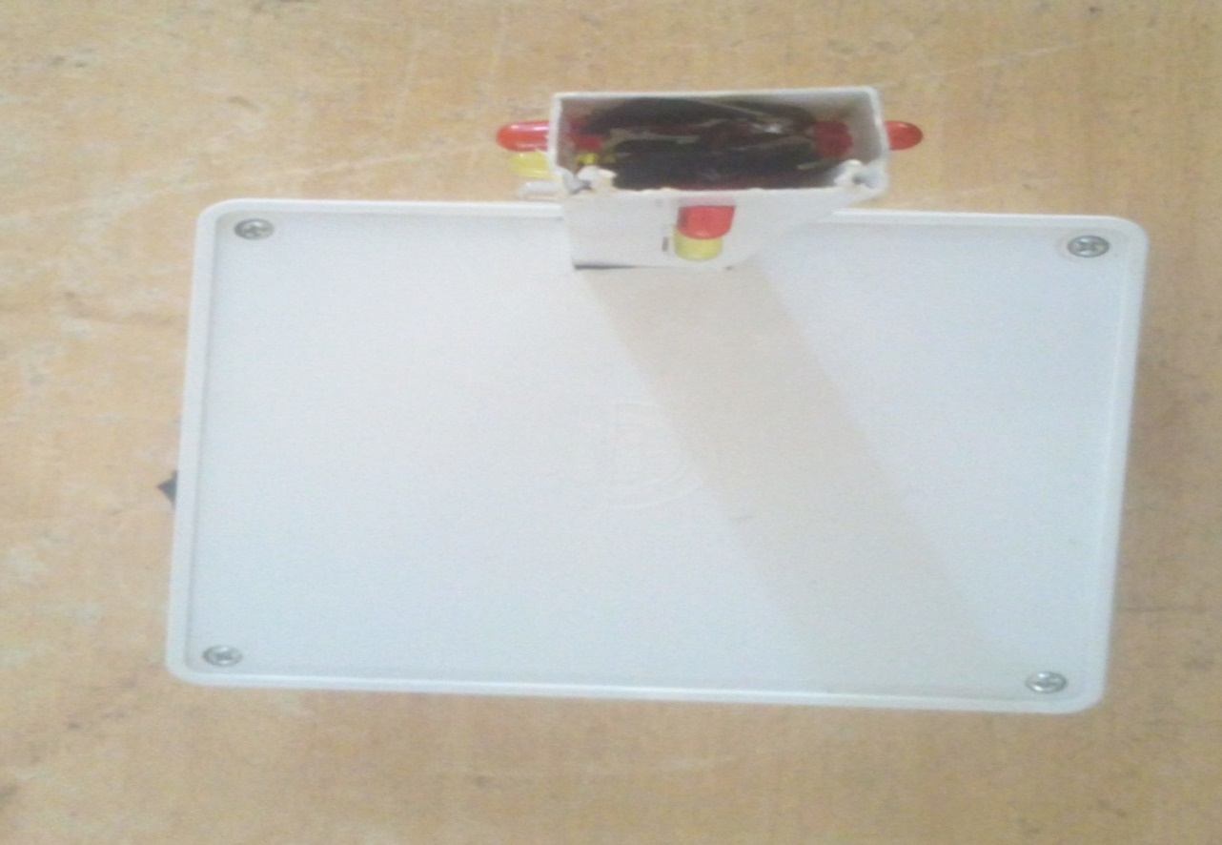

Figure 3.12: Casing

**3.4 Principle of Operation**

The real time traffic light controller is a complex piece of equipment which consists of power cabinet, main controller and displays. In this project, a simple traffic light system for a 4 way intersection is implemented using Arduino microcontroller. It gives an idea of the process behind the traffic light control system Consider the following gif image showing a loop of traffic light operations. The project is also implemented in the same manner.

In that, first the Lane 1 gets its Green light turned. Hence, in all the other Lanes, their corresponding Red lights are turned on. After a time, delay of predefined time says 5 seconds, the Green light in the Lane 3 must be turned on and the Green light in the Lane 1 must be turned off.

As a warning indicator, the Yellow light in Lane 1 is tuned on indicating that the red light is about to light up. Similarly, the yellow light in the Lane 3 is also turned as an indication that the green light about to be turned on.

The yellow lights in Lanes 1 and 3 are turned for a small duration say 2 seconds after with the red light in the Lane 1 is turned on and green light in Lane 3 is also turned on.

The green light in Lane 3 is also turned on for a predefined time and the process moves forward to Lane 4 and finally Lane 2.

The system then loops back to Lane 1 where the process mentioned above will be repeated all over again.

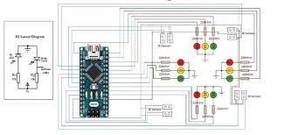

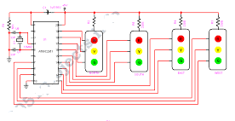

Figure 3.13: circuit diagram

**CHAPTER FOUR**

**4.0 Testing Result and Discussion**

This chapter explains how the device is tested and implemented under the following subheadings;

1. Testing
2. Result
3. Discussion
4. Bill of engineering measurement and evaluation

**4.1 Testing**

In order to achieve the objectives of the project four-way traffic light, several hardware components and software tools are employed and used after they have been selected among other alternatives due to some reasons and circumstances. In this section, the prototype system is tested to determine the status of the components used and the operational status of the constructed project.

**4.1.1 Sectional Circuit Testing**

The circuit component was tested one after the other to make sure they are in good working condition before they were mounted on the strip board and was also tested base on the circuit diagram before soldering.

**4.1.2 Prototype Testing**

The project was subjected to tests at the end of the construction although the first test way done on a solders board (bread board) before proper soldering.

A test was also conducted at the end of the construction to ensure proper and efficient function of the system. I n confirmation, phase 1, 2 and 3 indicates yellow, red and green respectively for a period of 15 seconds and then the other two followed sequence as designed. The performance evaluation of the traffic system was carried out. The model testing was performed at different occasions of light changing and the result below was achieved.

Initial time of operation of all the lanes = 2 seconds Amber duration = 3 seconds.

Red duration = 8 seconds Green duration = 4 seconds 1 = On

0 = Off

**4.2 Result**

The project was constructed on Vero board, in which the size of the main panel board was used to choose the dimension of the casing used. Many considerations were put in place in form of the procedure and instruction, which led to the successful completion of the project.

Table 4.1: Sectional test result

|  |  |  |  |  |
| --- | --- | --- | --- | --- |
| S/N | Test points | Test tool | Result | Comment |
| 1 | Transformer | Ohmmeter | Prim Coil =1.5k  Sec Coil= 150Ω | ok |
| 2 | Resistor | ohmmeter | All within +/- 5% | ok |
| 3 | Switches | Continuity | continuous when pressed | ok |
| 4 | LEDs | Diode tests | Vf = all >=0.7V | ok |

Table 4.2: Performance test result

|  |  |  |  |  |
| --- | --- | --- | --- | --- |
|  | North | East | South | West |
| Red | 1 | 0 | 1 | 0 |
| Amber/Yellow | 1 | 1 | 1 | 1 |
| Green | 0 | 1 | 0 | 1 |

**4.3 Discussion**

The result of the test given in table 4.1 show that the battery before operation commence is full and of the correct terminal potential of 9V as shown or stated in the design section. Also, the switch is functional as it gives continuity whenever it is closed implying that when in operation it can effectively switch the circuit ON and OFF. It also shows that the connection of the circuit is correct and that the components are not faulty. All voltage levels conform with the expected value from the design, it also means that there are no short circuits or open circuits. The results on table 4.2 show that the design and construction of a Prototype traffic light control system for crossroad was developed with the following results.

1. Automatic on and off operation of traffic light.
2. Increment assignment to the busiest lane.

From which it can be deduced that the Initial time of operation of all the lanes = 2 seconds Amber duration = 3 seconds. Red duration = 8 seconds Green duration = 4 seconds 1 = On

0 = Off, from which it is evident that the system is truly functioning as a four-way traffic light system.

**4.4 BEME Table**

The completed work is costed to complete the engineering documentation for future decisions. The table of cost estimate or BEME is give n in table 4.3.

Table 4.3: BEME Table

|  |  |  |  |  |
| --- | --- | --- | --- | --- |
| S/N | Component | Unit Cost (#) | Quantity | Amount (#) |
| 1 | Microcontroller | 6000 | 1 | 6000 |
| 2 | Fixed resistor | 100 | 4 | 400 |
| 3 | Battery | 400 | 1 | 400 |
| 4 | Light emitting diode | 100 | 12 | 1200 |
|  |  |  | Total (#) = | 9,000 |

**CHAPTER FIVE**

**5.0 Summary Conclusion and Recommendations**

This chapter presents the significance of the study and stresses the findings upon which a conclusion(s)is drawn in line with the objectives set, it acknowledges the limitations and suggests/ recommends further improvement / research which may be carried out on the topic.

**5.1 Summary**

This section of this project forms the conclusion part of the write up and take a look at some of the problem encountered during the progressive job of the system.

The design, construction and development of this project has really been challenging, as we have been face with choice far beyond what we expected. but in the long run the result paid off and was successful, despite the short period of time.

**5.2 Conclusion**

In conclusion, it is pertinent to state that despite all the hitches arising from the unavailability of components and materials and technological drawbacks, the design and construction of this four way traffic light control was successfully realized. And as a matter of fact, since we are in a technological advancing world, I strongly believe that it takes nothing less than pure determination and the ability to respond to such changes to survive in the present rapidly improving standards of the world system. So being aware of all these challenges, I made special effort to examine the technological problems encountered and also made additional modification in order to enhance the services of this design. The traffic light has been introduced constructed implemented and tested with the output found complying with the expectation and purpose of the project the project was tested at both the stages Red, Yellow and Green each confirm the device reliability the traffic light uses. Automatic traffic lighting system is useful equipment for controlling traffic flow at junctions.

This method has for long outweighed1 the older system in many ways it is more efficient and effective as well, as it can enhance the transportation system of the country saving many hours usually lost in traffic problems. Accidents may also be prevented and lives can be saved

**5.3 Recommendations**

Automatic traffic light control system is useful equipment for controlling traffic at junctions. More attention should be given to this method of automatic traffic light system by the government, individuals and even drivers as it posed to reducing or preventing road accidents thereby reducing or preventing loss of live associated with it.

The government should endeavor to encourage the installation of this system of traffic at necessary junctions in order to reduce the number of accounts associated with road.

Drivers and pedestrians should also learn to abide by the rules associated with the system so as to ease traffic congestion and avoid unnecessary stress on the road and fear of crossing intersections by the pedestrians.

Higher institution of learning most especially engineering fields should devote time and resources to the project as it would be of great benefit to students and researchers.

It is our belief that a greater design can be achieved if standard equipment, materials and components are used. We could not fail to commend that this design still stands much room for improvement.

Finally, we will like to suggest that the time limit for the project is not enough, because project construction need enough time.

**References**

*Boylestad L. and Washisky L. (2005); electrical device and circuit theory, 8th edition, prentice Hall of India limited, India.*

*Carter (1961); The burean ofpublic road of the U. S. Department of Transportation.*

*Douglass R.(1987); Fundamental of electronics, Breton publishers, 2nd edition , USA. Page 220 ­– 231.*

Ekinhan E., Sudi M., Dela J. an Su W. (2013). New method for designing traffic signal timing at oversaturated intersections. International Journal of Power Electronics and Drive System (IJPEDS). 8(2): 2088-8694

*Graham, (1991); Electronic principle and Aplications sigma press; First Edition, UK. Page 510 –523.*

Gustav N. and Giacomo C. (2014). Dynamic feedback traffic signal control policies based on a generalized proportional allocation rule. Mathematical journal. Presented at the 4th international conference in computational analysis. Paris 2014. Pub. IJPR 6-2:56-59

*Hontwrite P. and Hill W. (1996); the art of electronic, 2nd edition, press syndicate of the university of Cambridge GB.*

Huajun C., Fhur J., Su M., and Jin H. (2015). Interaction between travellers’ route choice and

traffic signal control in a coherent framework. International Journal of Power Electronics and Drive System (IJPEDS). 8(2): 2088-8694

Ishant S. and Pardeep K. (2016). Senor bae intelligent traffic controller. International Journal of Power Electronics and Drive System (IJPEDS). 8(2): 2088-8694

Junchen J. and Xiaoliang M. (2018). Group-based signal control approach capable of making

decisions based on its understanding of traffic conditions at the intersection level. Asian Scientific Journal of Technology. Kur-Fin Conference Series. 12-4:23-30

Jianhua G., Cin Z., Hu L., and Lee D. (2017). New method for area-wide traffic signal timing optimization under user equilibrium traffic. International Journal of Current developments in science. IJCDS.12-3:12-15

*Lynw P. (1986); electronic system; 2nd edition Macmillian publisher, UK.*

*Malvino, McGraw Hill. (1980); Eperiments for transistor circuit approximation; third rdition UK Page 127 – 133.*

Mohammad A., Sanu K., Nur L. and Dhabi k. (2019). RL (Reinforcement learning) algorithms in the design of adaptive traffic signal controllers called actor-critic adaptive traffic signal controllers (A-CATs controllers). Jouranl of adaptic Control. JAC 11-7:29-33

Naren A. and Srivathsan S. (2010). Adaptive predictive signal control system that performed real time queue length estimation. International Journal of Current developments in science. IJCDS.12-3:12-15

Nasser R., Sabar H., Yusef A. and shili K. (2011). Control of movement of traffic on urban streets by determined the appropriate signal timing settings. International Jouranla of Pure an applied Technology. IJPAT. 23-4:12-17

Pavan K. and Kamala k. (2017). Adaptive traffic control systems with VANET, International Journal of Power Electronics and Drive System (IJPEDS). 8(2): 2088-8694

*Pignotoro J. (1956); safety in Road usage published in USA by McGraw Hill.*

*Watson J. Willey and Sons, (1989); Analoge and Switching circuit design using intergrated device, inc. 2nd edtion , UK. Page 107 – 116.*

Ramteke L., Mahesh K., and Chandrasekhar M. (2012). FPGA (Field Programmable Gate Array) controller based on Neuro-Fuzzy system thought provided effective solution for Traffic Control. European Committee for Electrotechnical Standardization: Brussels, Belgium. 14:21418–21452

Rongrong T. and Xu Z. (2013). TRANSYT traffic modeling software for optimal fixed-time

signal plan using VISSIM micro-simulation software to affirm. Asian Scientific Journal of Technology. Kur-Fin Conference Series. 12-4:23-30

***Abstract***

*This project work is on construction of an Arduino based traffic light system. A 3-way traffic light signaling device positioned at 3-way road intersections, pedestrian crossings and other locations to control competing flows of traffic. The road construction safety traffic light system designed to replace a manual traffic control on a road construction sites. This device can replace one or both flaggers during the two lane closures on the event of a road construction. The road construction safety traffic light system is considered one of the best device in work zone traffic flow control system. The device is a portable traffic light unit which can be best utilized in controlling traffic flow in a road construction site for long term or short term lane closures and to control two-way traffic in a single lane. By implementing new technologies in automating traffic flow in road construction site could possibly eliminate the usage of a conventional flagman at all times. The construction is made of electronic component both active and passive. The construction was done and the aimed of the construction was achieved this project write up is from chapter one to five each discussed on a related work.*